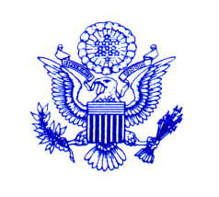

United States Department of State
Bureau of Educational and Cultural Affairs

Washington, D.C. 20522

www.state.gov

PARTICIPANT CONSENT & RELEASE FORM

FOR ALL PARTICIPANTS:

I, ______________________________, in connection with a U.S. Department of State-sponsored educational exchange program, hereby authorize the Department and its program implementing partners to photograph, film, or otherwise record and use my image and/or voice in connection with related public information programs and activities.

Additionally, I hereby authorize the Department and its implementing partners to release, publish, or quote such material, including my name, in connection with related public information programs and activities.

With respect to this material, I understand that content may be included in future speeches, on the Internet, and through multiple broadcast channels and print media (which may include use by U.S. Embassies abroad to promote Department exchange programs and public diplomacy efforts) but that such content will not be used for commercial purposes.

I understand that I may decline to give my consent (by not signing this Form) and still continue to participate in all exchange program activities without being disadvantaged with respect to those activities.

______________________________ ______________________________
Participant’s Signature Date
______________________________ ______________________________
Printed Name E-mail Address
______________________________
Participant’s Home City & Country

** FOR MINOR PARTICIPANTS **

I, ______________________________, as the parent or legal guardian of the Department’s program participant, grant the above consents and authorizations on behalf of my minor child or ward.
______________________________ _____________________________
Parent’s/Guardian’s Signature Date
______________________________ _____________________________
Printed Name E-mail Address

